EYE YANTRA OPERATION PROCEDURE:
General Instructions:
Before performing the Strabismus test, following things should be taken care of and proper procedures should be followed by the examiner as well as the patients:
- Body Posture: The patient should sit straight upright on the chair facing towards the camera. During the test, patient is kindly requested to restrict their head and eyes movement.

- Image: While performing the strabismus test, the image of the patient’s face primarily focusing on the eyes should be taken. Sometimes, images may contain small portion of shoulders as well which is fine if the eyes and corneal reflexes are clearly visible.

- Setting: The check-up room should be set in a dimly lit background to enhance the visibility of corneal light reflexes (especially for Hirschberg test). Black background is the most suited as it absorbs the maximum light and creates a high contrast so that the corneal reflex light is much more visible.

- Distance: The general distance between the camera and the forehead of the patient should be approximately in between 30-50 cm for conducting the strabismus test. The distance should ensure that the camera captures the image of the patient’s face with primary focus on the eyes.

- 9 Gaze Test: In 9 gaze test, general approach is to make the patient look on a fixed target like pen or any other object at 9 different locations. In our test, we use a black dot on white background and make patient focus on the black dot at 9 points and capture the images for our analysis.

Procedures:
- Open ‘Visual Studio Code’.
- Go to File>> Open Folder

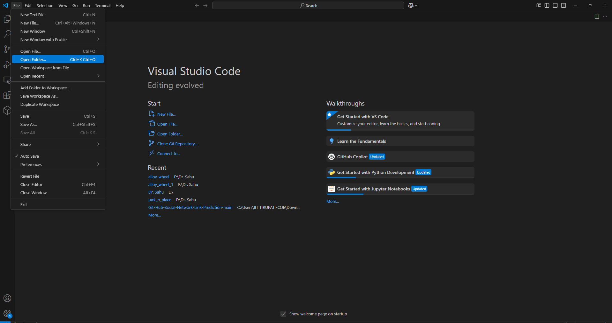
Fig: VS Code start page

- Specify the location and open the folder “Eye Yantra”.
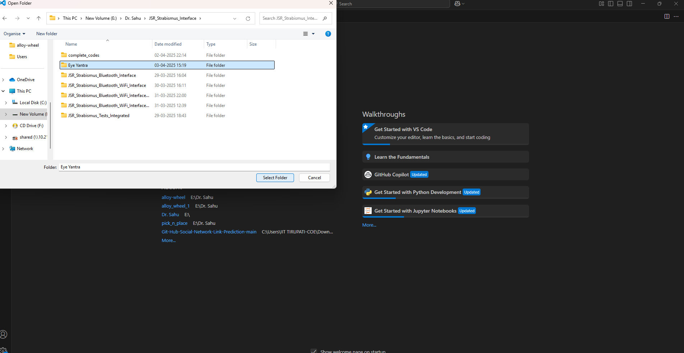
Fig: Opening the folder

- Power the Eye Yantra Device by any of the following ways [Red LED ON indicates that the device is running]:
  - Connecting MicroUSB to the AMB82 mini IoT controller
  - Switching ON the battery power supply

🔁 Step 2: Setup a Virtual Environment

▶️ On Ubuntu (terminal inside VS Code):

# Step into your project folder if not already there
cd /path/to/your/project

# Create a virtual environment
python3 -m venv venv

# Activate it
source venv/bin/activate

▶️ On Windows (VS Code terminal or PowerShell):
powershell
cd path\to\your\project

# Create a virtual environment
python -m venv venv

# Activate it
.\venv\Scripts\activate

📦 Step 3: Install Dependencies

▶️ On Ubuntu:

pip install -r requirements_ubuntu.txt

▶️ On Windows:

pip install -r requirements_windows.txt

🚀 Step 4: Run the Flask App (app1.py)

▶️ Run with:

python app1.py
⚠️ On Ubuntu, use python3 if python doesn’t point to Python 3.

🌐 Step 5: Access the App
Once running, Flask will usually say:
csharp
Running on http://127.0.0.1:5000/
Open a browser and go to: http://127.0.0.1:5000

- Click on “Connect” to connect the AMB82 device.
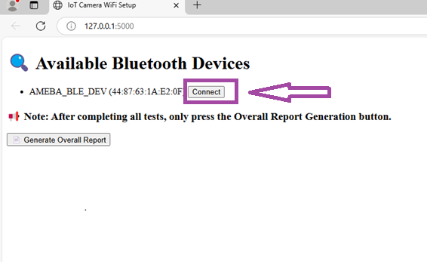
Fig: Bluetooth connection of device

- Then, Enter the network credentials and click on “Send WiFi Credentials”.
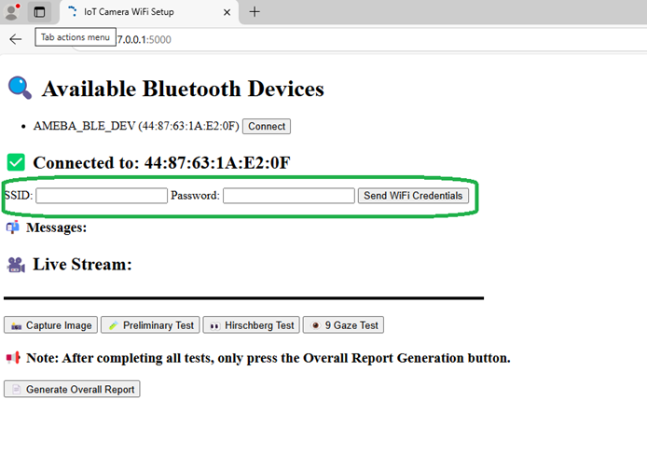
Fig: Internet connection to controller

- After connecting to the WiFi, video streaming initiates and the device is ready to perform tests.
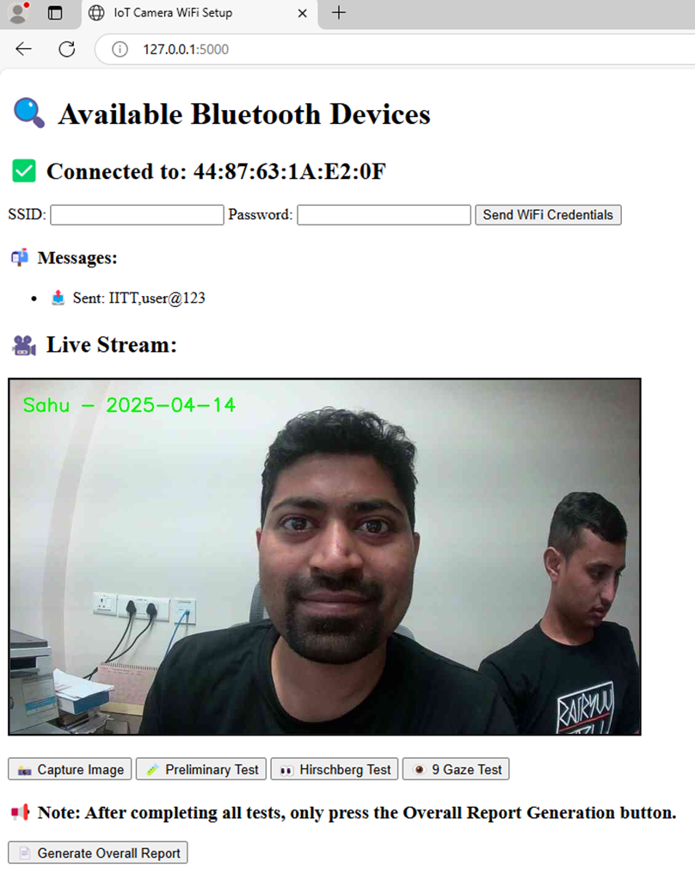
Fig: Initializing video streaming

INITIALIZING STRABISMUS TESTS:
- Preliminary Tests

- Click on the Preliminary Test and a new interface appears:
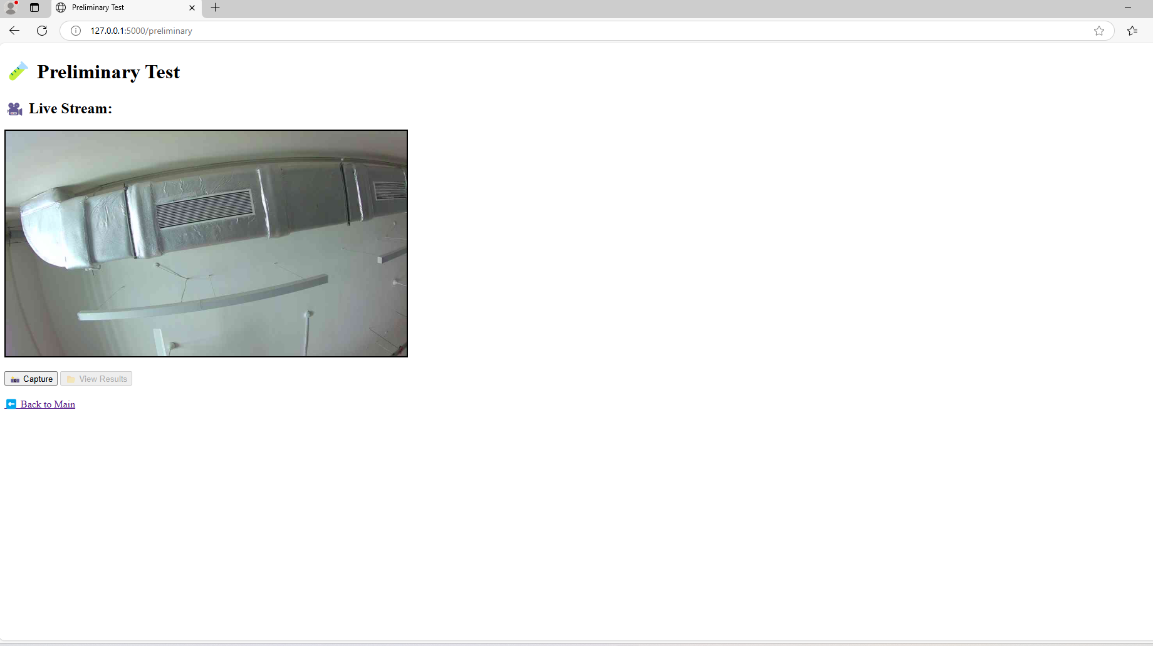
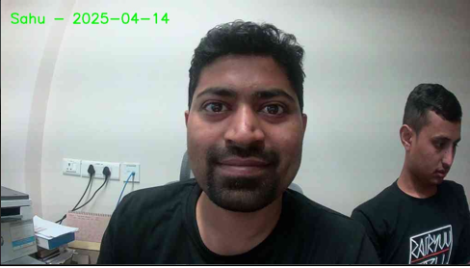
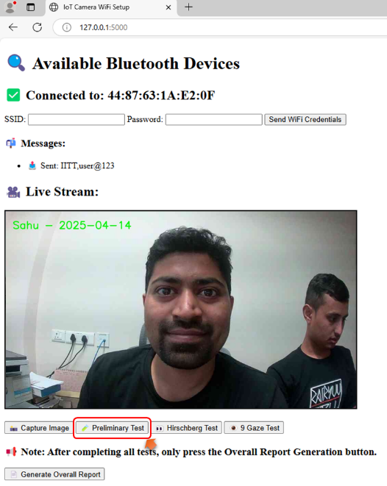
Fig: choosing preliminary test Fig: Preliminary test interface

- Place the device at the exact position with camera targeting the patient’s eye and click on “Capture” and enter the patient’s name.

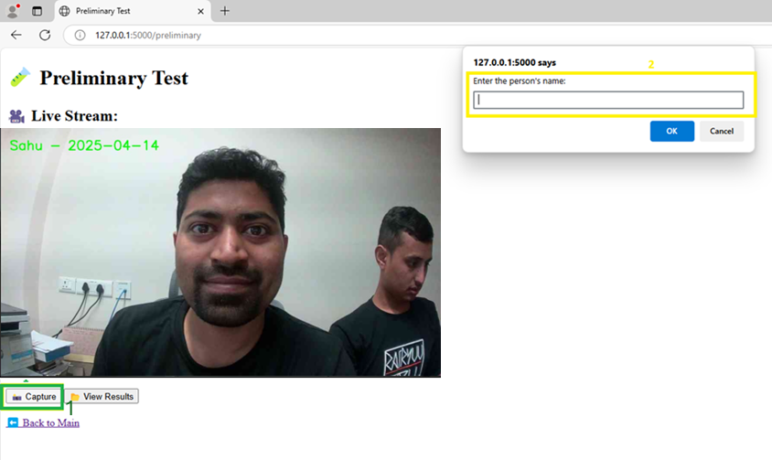
Fig: capturing the image

- Click on ‘View Results’ to see the results of the Preliminary Test.
- Click on ‘Back to Main’ to return to the home screen for further tests.

- Hirschberg Test
- Click on ‘Hirschberg Test’.

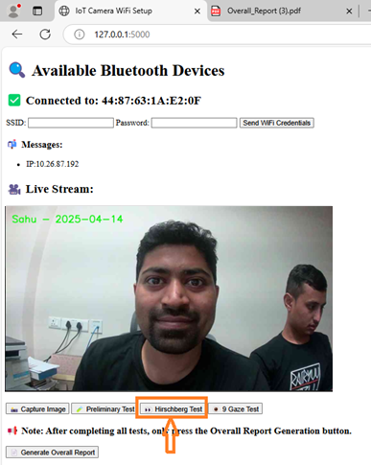
Fig: choosing Hirschberg test

- A new screen appears as:
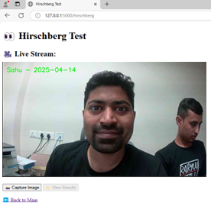
Fig: Hirschberg test interface

- Place the device at the exact position with camera targeting the patient’s eye and click on “Capture” and enter the patient’s name.
Note: The background shouldn’t be exposed to a bright setting because Hirschberg test contains use of LED light whose reflection in the iris centre is measured for operating the tests.
- Click on ‘View Results’ to see the results of the Preliminary Test.
- Click on ‘Back to Main’ to return to the home screen for further tests.
- Nine Gaze Test
  - Click on ‘9 Gaze Test’.
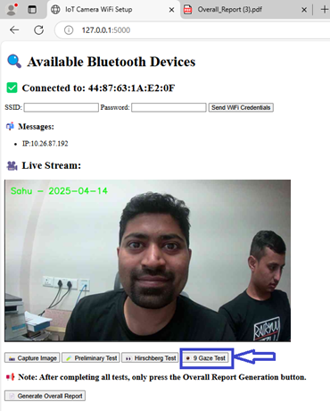
Fig: choosing 9 gaze test
  - A new screen appears as:

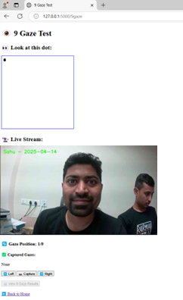
Fig: 9 gaze test interface

  - Firstly, click on Capture and enter the patient’s name.
Note: The patient should focus the black dot on the white background.
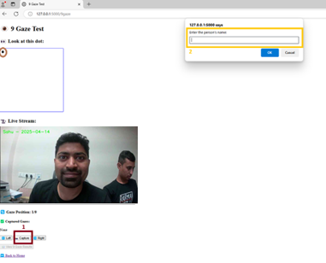
Fig: capturing image for 9 gaze test

  - Then, click on the ‘Right’ to change the position of ‘black dot’.
Note: You can see the current ‘Gaze Position’ and the ‘Captured Gazes’ in the screen.
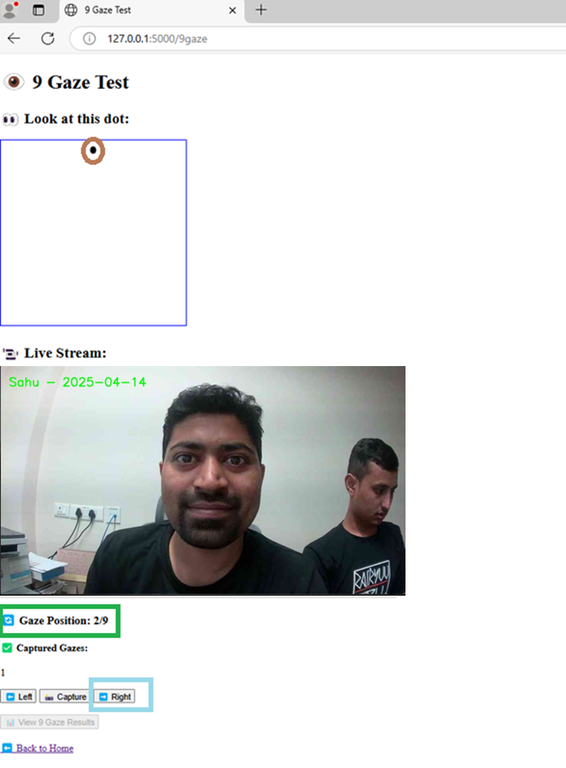
Fig: changing the gaze position

  - Repeat the same process for capturing 9 images while the patient focuses on the 9 different gazes displayed on the screen.

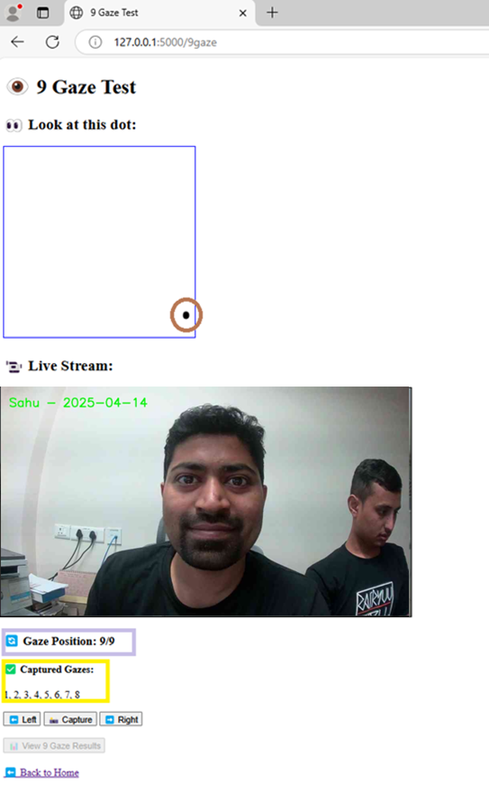
Fig: depicting final gaze position and captured gazes

  - Click on ‘Back to Home’ and return to the home screen.

OVERALL REPORT
After completing all the three tests, we need to generate overall results of the test for further analysis and treatment(if necessary). For that purpose, we can view results of all the tests in a single pdf file by following the below steps:
- On the home screen, click on ‘Generate Overall Report’ and click ‘OK’.
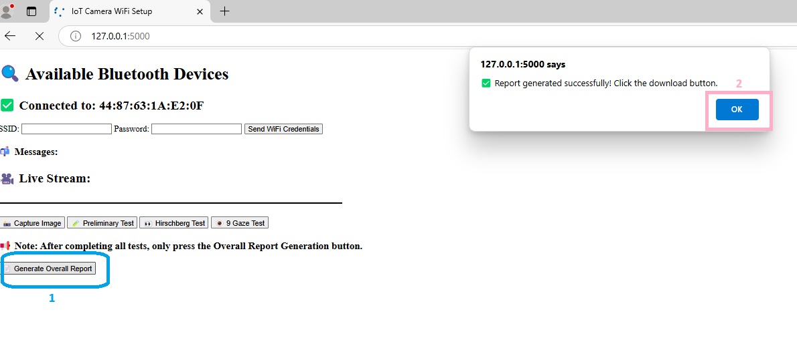
Fig: overall report generation
- Click on ‘Download Overall Report’:
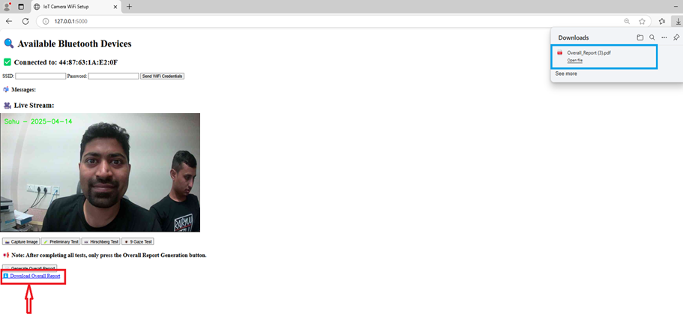
Fig: downloading overall report
- Then, you can open the pdf file containing ‘Overall Report’ of the Patient and detect the degree of Strabismus in their eyes.

Eye Yantra:
Eye Yantra is the device that is used for performing the Strabismus Detection Test. The components of the device are:
- Housing: The housing is fabricated using 3D printer and the material is PLA. There are two compact cases manufactured according to the need of the interior components.
- AMB82 Mini IoT Controller: It is the development board used for creating Internet of Things(IoT) applications with Artificial Intelligence(AI) capabilities. We have used this controller because it has multiple advanced features like high resolution AI camera, microphone, 23 General Purpose Input Output (GPIO) pins, default microphone, Bluetooth and Wi-Fi connectivity, internal memory and additional SD card slot and so on.
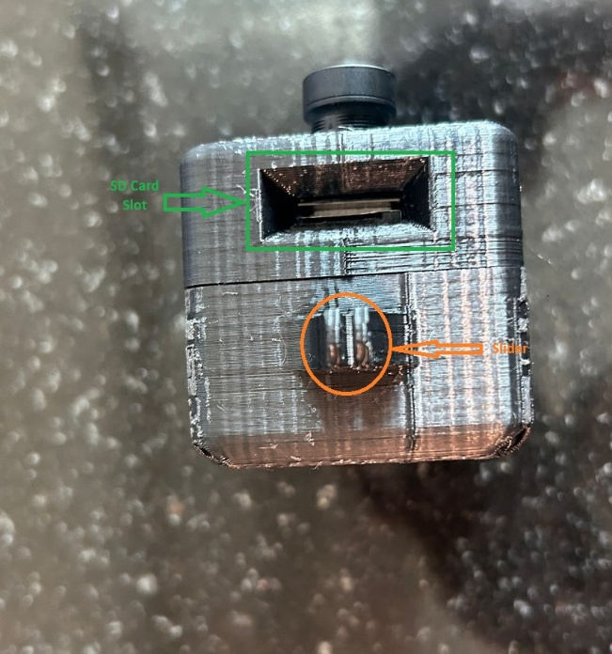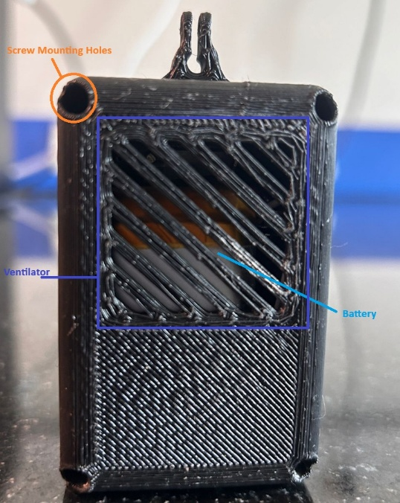
Fig: top view of Eye Yantra Fig: back view of Eye Yantra
- Battery: We have used 3.7 V 1500 mAh Lithium Polymer(LiPo) battery which is used to supply the external power to the controller.
- Rechargeable Boost Converter: In this project, a single board containing the integrated voltage boost converter and charging module is used. This component takes 3.7 V input from the LiPo battery and steps up to 5.2 V so as to power the AMB82 controller. The LiPo battery can be recharged using the micro-USB charging port present in the module.
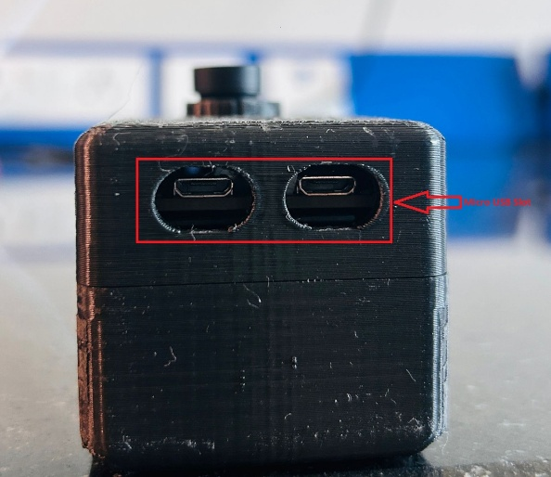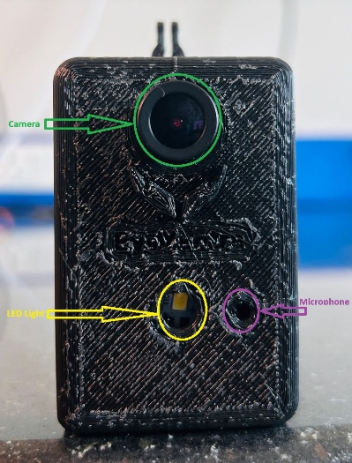
Fig: bottom view Fig: front view
- Slide Switch: It is used for switching purposes. While operating the device to perform strabismus test, the switch is turned ON and the power flows from the battery to the controller. While not in use, we turn the switch OFF, which opens the circuit and restricts power flow. It helps to prevent battery charge for a long time without discharging.
- Screws: To assemble the two cases, we have used four number of M2.5*8 screws. We have used two screws of same size to mount the rechargeable boost converter.

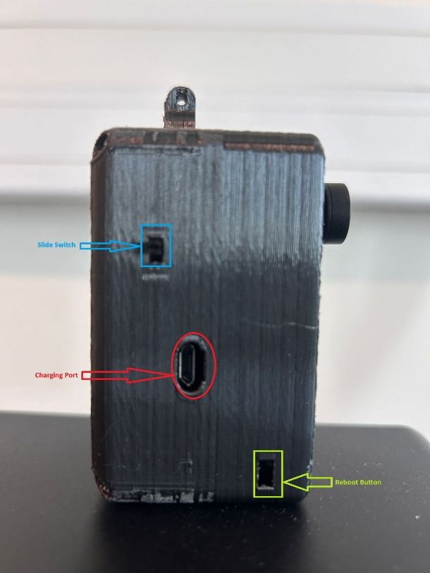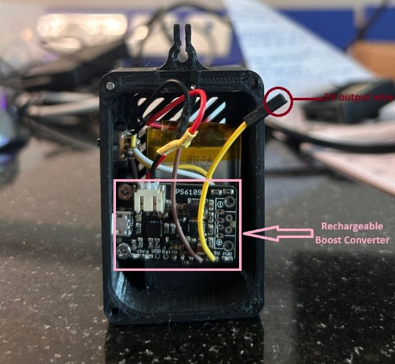
Fig: side view Fig: interior view

